Egyptian E-Learning University

Faculty of Computers & Information Technology

  - MINDFUL
Mental Health Support Platform
By
Abdelrahman Mohamed Mohamed | 2102284
Waleed Khaled Edrees | 2102174
Sama Yasser Gemeaey | 2101552
Seham Samy Ebrahim | 2101580
Mohamed Ayman Fouad | 2101175
Mohamed Ayman Elkhawas | 2102032
Mohamed Ashraf Mohamed | 2101188

  - Supervised by
Dr. Rodaina Abdelsalam
  - Assistant
Eng. Martina Girgis
[Alexandria]-2025

Abstract
This project "MindFul" addresses the critical need for accessible and destigmatized mental health support in Egypt. Mental health issues affect a significant portion of the global population, with approximately 1 in 8 people experiencing mental health disorders worldwide. The platform aims to bridge the gap in mental health care by providing comprehensive resources and fostering a supportive community.
The methodology involves leveraging modern technology to create a responsive and intelligent system. Key components include AI-powered psychological tests for initial assessments, an AI-driven chatbot utilizing Retrieval-Augmented Generation (RAG) with the Mixtral-8x7B-Instruct-v0.1 model for empathetic support, a dedicated section for sharing personal stories, and a directory of licensed mental health professionals. The front-end is built with React, HTML, CSS, and JavaScript, while the back-end uses Node.js, Express.js, and MongoDB.
Key results include the development of predictive models for panic disorder, social media mental health, and anxiety prediction. The RAG-based chatbot ensures accurate and context-aware responses by integrating external, reliable knowledge sources. MindFul's unique approach focuses on cultural relevance for Egyptians, doctor-approved content, and a community-driven solution, aiming to improve quality of life and foster healthier societies.

Acknowledgments
We would like to express our sincere gratitude to everyone who supported and guided us throughout the preparation of this graduation project.
First and foremost, we would like to thank our supervisor, Dr. Rodaina Abdelsalam, for her continuous support, valuable feedback, and insightful guidance, all of which contributed significantly to the successful completion of this project.
We also extend our sincere appreciation to the faculty members, especially Eng. Martina Girgis, for their encouragement and academic support.
We are truly grateful to our families and friends for their unwavering encouragement, patience, and moral support throughout this journey.
Finally, we would like to thank every member of our team for their dedication, cooperation, and hard work, which made this project possible

Contents
Abstract 2
Acknowledgments 3
Table of Figures 6
Introduction 7
1.1 Introduction 8
1.2 Background and motivation for the project 8
1.3 Importance of the problem being addressed 9
1.4 Problem Statement 9
1.5 Objectives 10
Literature Review / Related Work 13
2.1 Overview of Related Research and Technologies 14
2.2 Limitations of Current Solutions Addressed by Mindful 15
2.3 Summary 17
Proposed system 18
3.1 Approach used to solve the problem 19
3.2 System architecture 20
3.3 Algorithms or frameworks used 26
Implementation 28
4.1 Technologies, tools, and programming languages used 29
4.2 Key components/modules of the system 38
4.3 Challenges faced and how they were resolved. 39
Testing & Evaluation 42
5.1 Testing strategies (unit testing, integration testing, user testing) 43
5.2 Performance metrics (accuracy, speed, scalability, etc.) 45
5.3 Comparison with existing solutions (if applicable) 46
Results & Discussion 48
6.1 Introduction 49
6.2 Summary of findings 49
6.3 Interpretation of results 50
6.3 Limitations of the proposed solution 51
Conclusion & Future Work 53
7.1 Summary of contributions 54
7.2 Possible improvements or extensions for future work 55
References 57
Appendices 60

Table of Figures
Figure 1 Use Case Diagram 20
Figure 2 Sequence Diagram 21
Figure 3 Class Diagram 22
Figure 4 ER Diagram 23
Figure 5 DB Schema 24
Figure 6 Activity Diagram 25
Figure 7 Accuracy of models for Panic Disorder detection. 32
Figure 8 Accuracy of models for Social Media Mental Health 33
Figure 9 Accuracy of models for Anxiety 34
Figure 10 RAG Architecture 36
Figure 11Prompt 37
Figure 12 Performance comparison between LLaMA 2 70B, GPT-3.5, and Mixtral 8x7B 62

Chapter 1

Introduction

1.1 Introduction
Mental health is a critical aspect of overall well-being, influencing how individuals think, feel, and act. It affects daily functioning, relationships, and coping with life's challenges. Good mental health allows people to realize their potential, work productively, and contribute to their communities. It is an essential component of overall health and well-being, forming the foundation of our ability to make decisions, build relationships, and shape the world around us. Mental health is a basic human right and a crucial factor in personal, community, and socio-economic development.

1.2 Background and motivation for the project
In today’s fast-paced and increasingly demanding world, mental health has become more critical than ever. Millions of people worldwide are affected by psychological issues such as anxiety, depression, and mood disorders, which have a profound impact on their quality of life and relationships. Despite its importance, mental health is often overlooked, and many people face barriers to seeking support due to stigma, lack of awareness, or limited access to care. Although awareness of mental health is growing, many individuals still lack sufficient knowledge about mental health disorders and their symptoms. This knowledge gap often leads to delayed intervention and limited access to support.

1.3 Importance of the problem being addressed
Despite significant progress in raising awareness, stigma and misconceptions surrounding mental health continue to persist. Many individuals suffer in silence due to fear of judgment and discrimination. As a result, they may avoid seeking help, which can worsen their condition and increase their distress. In addition, access to quality mental health services remains limited, particularly in underserved and marginalized communities. Mental health conditions include mental disorders, psychosocial disabilities, and other mental states that are associated with significant distress, impaired functioning, or an increased risk of self-harm. Various psychological and biological factors—such as emotional regulation skills, substance use, and genetics—can increase an individual's vulnerability to mental health issues. Addressing mental health is essential for improving quality of life and fostering healthier, more resilient societies.

1.4 Problem Statement
Clearly Defined Project Problem: Mental health is often stigmatized in Egypt, making it difficult for individuals to seek help. Access to professional mental health support is limited, especially in rural areas. Many individuals struggle to find reliable mental health resources or assistance. There is a lack of awareness about mental health issues, contributing to the problem. The absence of a centralized platform makes it harder to address mental health concerns effectively. Social stigma, lack of awareness, high cost of treatment, limited access in remote areas, privacy concerns, lack of community and family support, and limited availability of doctors are all significant challenges.

Why This Problem Needs to Be Solved: Mental health issues impact a significant portion of the global population, with approximately 1 in 8 people—over 970 million individuals—experiencing mental health disorders worldwide, according to the World Health Organization [1]. These disorders contribute to around 15% of the global disease burden, underscoring mental health as a critical public health concern. Suicide due to deteriorating mental health is a serious global issue affecting individuals and communities alike, with approximately 700,000 people dying by suicide every year [2], making it the third leading cause of death among young people. This project has the potential to positively impact lives by providing timely support and improving the quality of life for individuals affected by mental health issues. By addressing these problems, MindFul aims to combat stigma, increase awareness, improve accessibility, and provide reliable resources for mental well-being.

1.5 Objectives
Main Objective: The main objective of MindFul is to harness the power of modern technology and data science to create an accurate, efficient, and accessible platform that bridges the gap between individuals and mental health support systems. It aims to provide comprehensive mental health support through an integrated platform with psychological testing, stories, chatbot, and patient accounts.
Specific Objectives:
- Reduce stigma: Combat stigma by providing accessible mental health resources.

- Increase accessibility: Create a user-friendly platform with tools like chatbots and psychological tests.
- Enhance personalization: Utilize AI and machine learning for personalized support.
- Facilitate connection: Provide a directory of doctors with their locations for easy access to professional help.
- Promote awareness: Increase awareness about mental health issues through educational articles, stories, and positive notifications.
- Provide privacy and security: Ensure a safe and supportive environment that protects users' personal and health information.
- Offer low-cost solutions: Address the high cost of mental health treatment by providing accessible resources.
- Ensure 24/7 availability: Provide web-based accessibility to support services anytime and from any location.
  - Brief overview of the proposed solution.
MindFul offers a comprehensive platform designed to enhance access to mental health resources. It includes:
- AI-Powered Psychological Testing: Tools and assessments to evaluate mental health conditions based on machine learning algorithms.
- AI-Driven Chatbot: An intelligent assistant using RAG and Mixtral-8x7B-Instruct-v0.1 that engages with users to provide immediate guidance and emotional support, fine-tuned on mental health counseling conversations dataset.
- Stories Section: A safe space for users to discuss, share experiences, and support one another, fostering community and reducing isolation.

- Therapists Section (Doctor Directory): Enables users to access licensed mental health professionals by providing their locations, availability, and contact information, bridging the gap between tech and real-world expertise.
- Mental Health Articles: A dedicated space where doctors can publish informative content to raise awareness and provide guidance.
- Positive Notifications: Regular motivational messages and mental wellness tips designed to uplift users and encourage a positive mindset.

The platform leverages a modern and efficient technology stack, including HTML, CSS, JavaScript, React for the front-end; Node.js, Express.js for the back-end; and MongoDB for database management. AI integration features predictive models like XGBoost for panic disorder detection, Logistic Regression for social media mental health assessment, and SVM for anxiety prediction.

Chapter 2

Literature Review / Related Work

2.1 Overview of Related Research and Technologies
Mental health support platforms have become increasingly prevalent, leveraging technology to offer various forms of assistance. Existing solutions often fall into categories such as online therapy platforms, AI-powered chatbots, and community-driven forums.
Research in mental health prediction using machine learning has explored various models. Studies have experimented with Random Forest for predicting depression and anxiety with up to 90% accuracy, and XGBoost for handling imbalanced data and delivering fast results. Specifically, research on Panic Disorder detection has tested SVM, DecisionTreeClassifier, RandomForestClassifier, and XGBoost Classifier, with the latter achieving high accuracy. For chatbot development, Retrieval-Augmented Generation (RAG) has been proven effective in improving model performance, especially in medical and mental health contexts, by integrating external, reliable knowledge sources to enhance Large Language Models (LLMs). The Mixtral-8x7B-Instruct-v0.1 model has been identified as a state-of-the-art choice for intelligent interactions [3], fine-tuned using mental health counseling conversations datasets. Our adoption of the RAG approach and the Mixtral-8x7B-Instruct model was based on insights from Nayinzira & Adda (2024) [4] and Mistral AI documentation. For mental health prediction, we reviewed and compared several ML models based on studies by Ezhilmaran & Kannan (2022) [5], Sumitha et al. (2023) [6], and Rahaman (2023) [7], which helped in choosing XGBoost for its accuracy.

Several competitors offer mental health services:
- Shezlong (Egypt & Arab World): This platform focuses on online therapy sessions with licensed therapists. Its strengths include the ability to choose therapists and availability in Arabic.
- Woebot (United States): Woebot is an AI-powered chatbot designed for mental health support. Its main strengths are 24/7 availability and instant support.
- BetterHelp (Global): BetterHelp provides online therapy sessions with licensed therapists globally. It offers access to licensed therapists globally and flexible communication options.

2.2 Limitations of Current Solutions Addressed by Mindful
While existing solutions offer valuable mental health support, significant gaps remain, particularly concerning cultural relevance, comprehensive features, and community integration, especially in the Egyptian context:
- Limited Community Features: Shezlong, while providing online therapy, lacks community features like story sharing or AI-powered tools. This indicates a gap in platforms that foster peer support and shared experiences.
- Absence of Human Interaction: Woebot, despite its 24/7 AI support, has no human therapist interaction. This highlights a need for platforms that combine AI with access to professional human help.

- Lack of Integrated AI and Community-Driven Features: BetterHelp, while global and flexible, does not incorporate community-driven features or AI-powered psychological tests. This points to a need for a more holistic platform that integrates advanced AI assessments with community support.
- Stigma and Awareness: Mental health is often stigmatized in Egypt, and there is a general lack of awareness about mental health issues, making it difficult for individuals to seek help. Current solutions often do not specifically address this cultural barrier.
- Limited Access to Professional Support: Access to professional mental health support is limited, especially in rural areas, and many individuals struggle to find reliable mental health resources or assistance. The absence of a centralized platform makes it harder to address mental health concerns effectively.
- Lack of Centralized and Culturally Relevant Platform: The existing options do not specifically cater to the unique mental health needs of Egyptians with a comprehensive, centralized platform that integrates community support, doctor-approved content, and advanced AI tools.

2.3 Summary
MindFul aims to fill these identified gaps by offering a unique, community-driven solution specifically tailored for Egyptians. It integrates a supportive community where users can share stories and connect, creating a safe environment. It also includes doctor-approved content, such as articles and posts by certified psychiatrists, to ensure reliability. Furthermore, it features AI-powered psychological tests where machine learning provides accurate, personalized assessments. A comprehensive psychiatrist directory allows users to find psychiatrists’ locations, availability, and contact information, bridging the gap between tech and real-world expertise. Its cultural relevance is tailored to address Egyptians' unique mental health needs. By combining these features, MindFul provides a more holistic, accessible, and culturally sensitive approach to mental health support.

Chapter 3

Proposed system

3.1 Approach used to solve the problem
The MindFul project addresses critical mental health challenges by implementing a multi-faceted, centralized digital platform designed to combat stigma, increase accessibility, enhance awareness, and provide reliable resources for mental well-being. Its key strategies include:
- Combating Stigma & Raising Awareness: MindFul provides a safe space for users to share stories and experiences, aiming to normalize mental health conversations. Doctor-approved content by certified psychiatrists ensures reliable information and promotes understanding, reducing stigma. Positive notifications further encourage self-care and a positive mindset.
- Improving Accessibility & Connection: The platform offers AI-powered psychological tests for initial assessments, providing insights from anywhere. An AI-driven chatbot offers immediate, 24/7 guidance and emotional support. A directory of licensed mental health professionals facilitates easy access to real-world expertise by providing their locations, availability, and contact information, addressing limited access, especially in rural areas. The web-based nature ensures constant accessibility.
- Personalization & Reliable Resources: Leveraging AI and machine learning, the platform offers personalized support through accurate psychological assessments. The RAG-enhanced chatbot provides context-aware and empathetic responses based on reliable knowledge sources.

3.2 System architecture
The MindFul system is designed with multi-tiered architecture to ensure scalability, efficiency, and maintainability. It consists of a front-end user interface, a back-end server, a database, and integrated AI modules.
The overall system structure and interactions are illustrated through various UML diagrams:
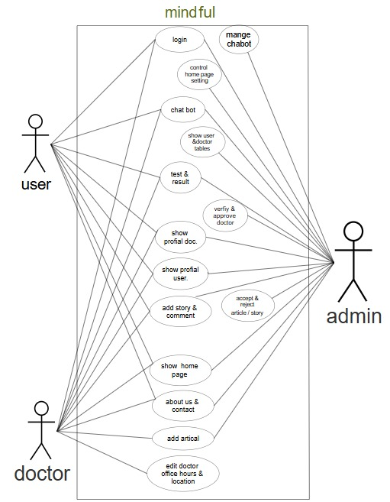
- Use Case Diagram: This diagram shows the interactions between different users (User, Doctor, Admin) and the platform's functionalities, such as sharing stories, chatting with the bot, taking tests, writing articles and posts, and approving content and managing accounts.
Figure 1 Use Case Diagram

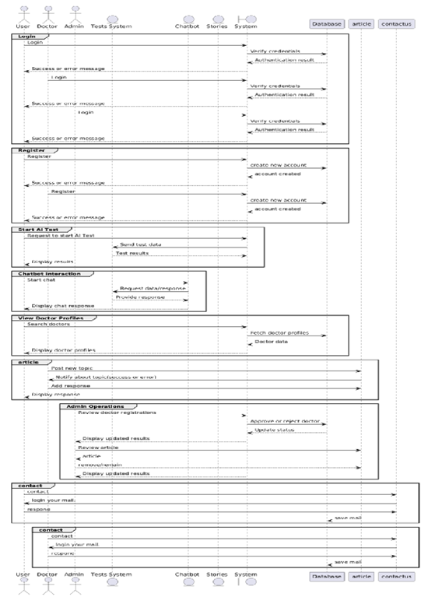
- Sequence Diagrams: These diagrams depict the chronological flow of interactions for critical processes within the system, emphasizing the sequence of message exchanges between components. Specific sequence diagrams cover Login, Register, Start Psychological Tests, Chatbot Interaction, View Doctor Profiles, Admin Operations, and Article posting.
Figure 2 Sequence Diagram

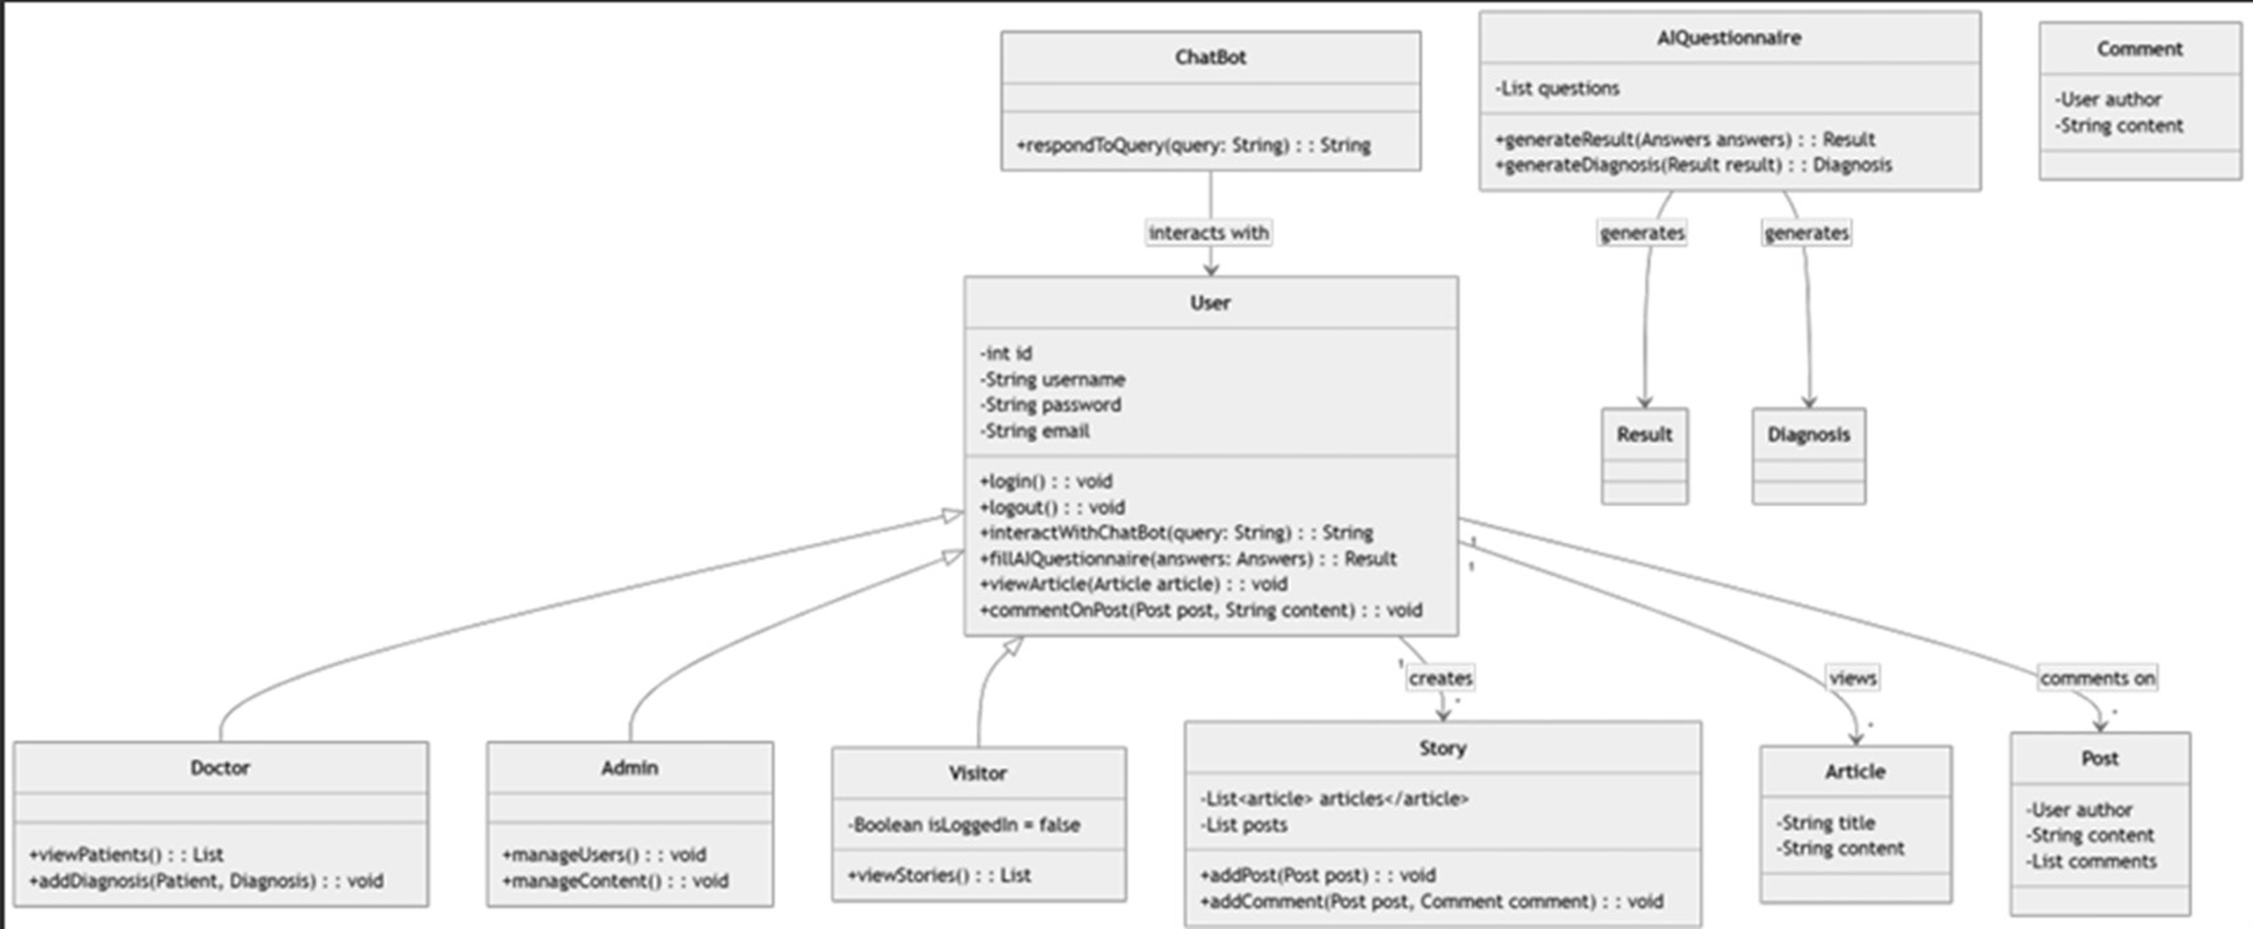
Class Diagram: This diagram defines the static structure of the system by representing classes, their attributes, methods, and the relationships between them.
Figure 3 Class Diagram

- Entity-Relationship (ER) Diagram: This diagram illustrates the logical structure of the database, highlighting entities, their attributes, and the relationships among them.
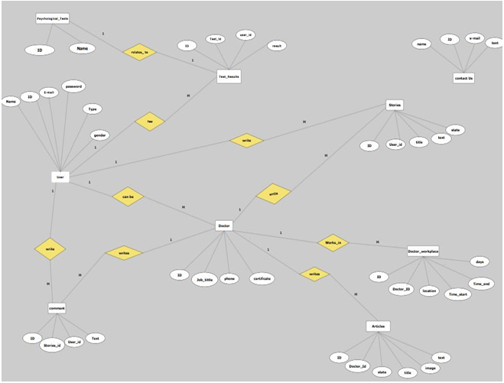
Figure 4 ER Diagram

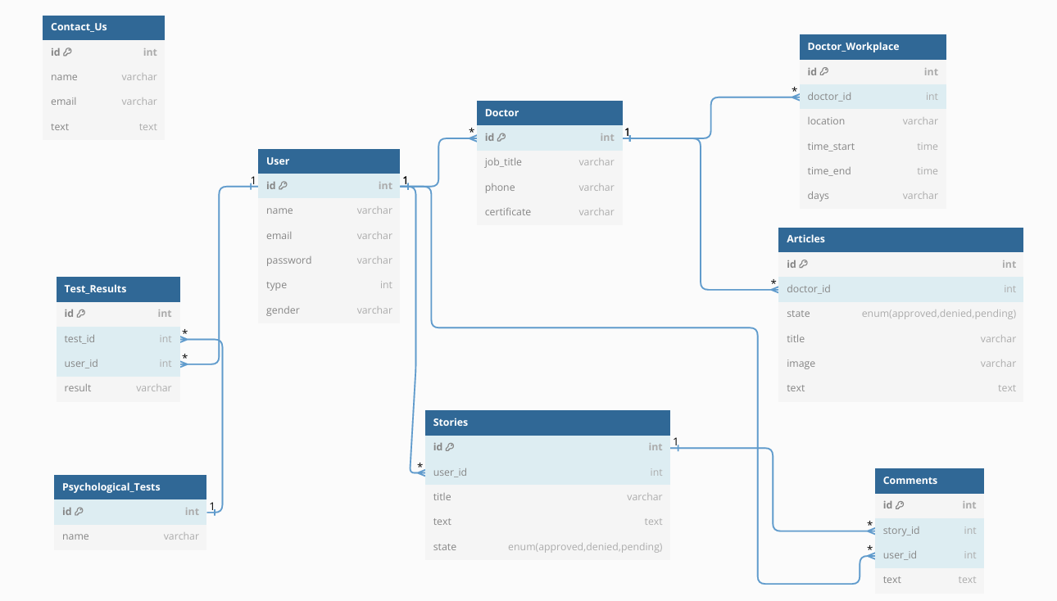
- Database Schema: Offers a detailed implementation-level view of the database design, including tables, data types, primary and foreign keys, and constraints.
Figure 5 DB Schema

- Activity Diagram: Represents the dynamic workflows and internal processes within the system, showing control flow from one activity to another.
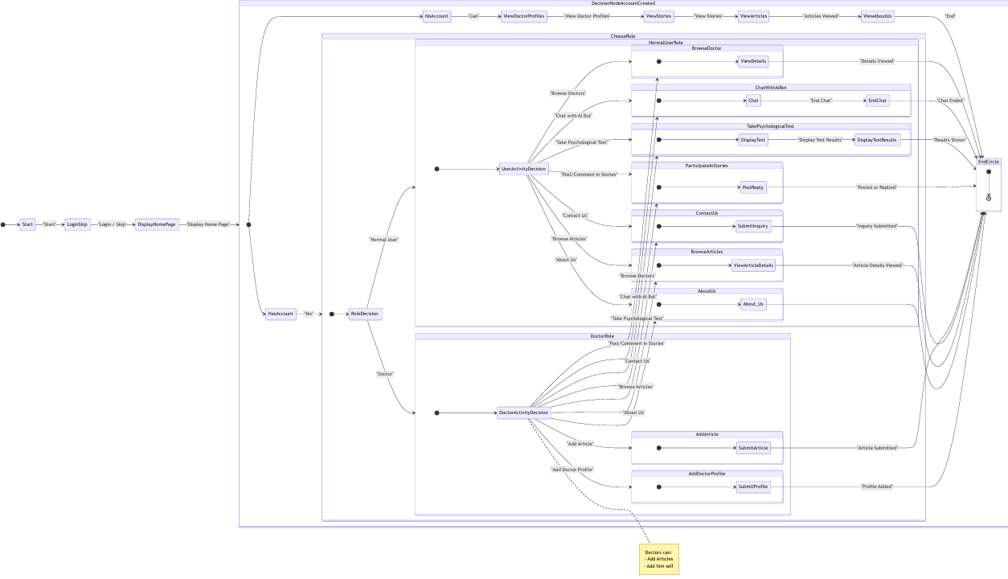
Figure 6 Activity Diagram

3.3 Algorithms or frameworks used
The MindFul platform leverages a robust set of technologies and algorithms across its front-end, back-end, and artificial intelligence components to deliver a responsive, intelligent, and accessible mental health support system.
- Front-End Technologies:
  - HTML, CSS, JavaScript: Core web languages for structure, styling, and interactivity.
  - React: A powerful JavaScript library for building dynamic and responsive user interfaces.
  - Bootstrap: Utilized for streamlined UI development and responsive design.
- Back-End Technologies:
  - Node.js & Express.js: A scalable runtime environment and a flexible framework for building efficient server-side applications and RESTful APIs.
  - MongoDB: A NoSQL database for flexible and scalable data handling.
- Artificial Intelligence (AI) Algorithms and Models:
  - AI-Powered Psychological Tests: Various machine learning models were experimented with to power the psychological assessments. Key models chosen for their accuracy in specific prediction tasks include XGBoost Classifier (for panic disorder), Logistic Regression (for social media mental health), and Support Vector Machine (SVM) (for anxiety prediction). General mental health prediction also explored Random Forest and Neural Networks.
  - Chatbot Using RAG and Mixtral:
    - Retrieval-Augmented Generation (RAG): An advanced technique employed to enhance the chatbot's ability to provide accurate and relevant responses by integrating external knowledge sources with a large language model. This approach is research-backed for medical and mental health contexts.
    - Mixtral-8x7B-Instruct-v0.1: A state-of-the-art sparse Mixture-of-Experts (MoE) model, chosen for its efficiency, performance, and open-source nature [8]. This model forms the core of the intelligent interactions within the chatbot, helping to identify symptoms and provide summaries.
- Key Tools and Libraries:
  - Pinecone: Used as a vector database, essential for RAG architecture.
  - Figma: For UI/UX design.
  - Axios: For efficient HTTP requests between front-end and back-end.
  - Vercel: For front-end deployment.

Chapter 4

Implementation

4.1 Technologies, tools, and programming languages used
The MindFul platform's implementation leverages a comprehensive stack of modern web technologies, development tools, and programming languages to ensure a responsive, interactive, scalable, and intelligent system.
- Front-End Technologies:
  - HTML5: Used to structure the content of the web application, providing semantic elements and built-in support for multimedia.
  - CSS3: Applied to control the presentation and layout of the HTML content. It enhances visual design and ensures responsiveness across various screen sizes using features like transitions and media queries.
  - JavaScript: Serves as the core scripting language for implementing interactive features, client-side logic, real-time user interaction, DOM manipulation, and API integration.
  - ReactJS: A powerful JavaScript library used for building reusable UI components and managing application state. It enhances performance through virtual DOM rendering and promotes modular and maintainable code.
  - Bootstrap: Integrated to streamline the UI development process, enabling rapid development of responsive, consistent, and mobile-first interfaces.
- Back-End Technologies:
  - Node.js: An open-source, cross-platform runtime environment that enables JavaScript code execution outside of a web browser. Built on Google Chrome’s V8 JavaScript engine, it is known for its speed and efficiency, making it ideal for building scalable and real-time applications.
  - Express.js: A minimal and flexible Node.js framework that provides a robust set of features for building web and mobile applications. It simplifies setting up routes, handling HTTP requests, and structuring back-end logic in a clean, maintainable way.
  - MongoDB: A leading NoSQL database that stores data as documents in a flexible, JSON-like format (BSON). Its schema-less nature makes it highly adaptable for evolving application requirements, and it excels in storing large volumes of unstructured data.
- Development Tools and Libraries:
  - Visual Studio Code (VS Code): A lightweight yet powerful source-code editor developed by Microsoft, supporting a wide range of programming languages and tools for front-end, back-end, and AI development.
  - Git and GitHub: Utilized for version control and remote repository hosting, enabling effective team collaboration, issue tracking, and a continuous development workflow.
  - Postman: A widely-used collaboration platform for API development, providing a graphical user interface for testing and documenting APIs during the back-end development phase.
  - Axios: A promise-based HTTP client for JavaScript, commonly used with frameworks like React. It simplifies making asynchronous requests to the server, streamlining communication between the client and server.
  - Vercel: A modern cloud platform designed for deploying front-end applications, offering seamless integration with GitHub for continuous deployment workflows and fast load times.
  - Pinecone: Used as a vector database for embedding similarity searches, particularly within the Retrieval-Augmented Generation (RAG) framework for the chatbot.
  - Hugging Face: Utilized to access pre-trained language models, specifically Mixtral-8x7B-Instruct-v0.1, for the chatbot implementation.
- AI-Powered Psychological Tests: The platform integrates three primary psychological tests designed to assess the likelihood of specific mental health conditions based on user input, leveraging distinct machine learning models and datasets. The goal is to select machine learning algorithms capable of accurately analyzing the results of psychological tests.
  - Panic Disorder Detection Test
Dataset: Panic Disorder Detection Dataset [9] sourced from Ayesha Clinic via clinical observations and records. It comprises 100,000 entries with 17 columns (15 features plus Participant ID and Panic Disorder Diagnosis). The dataset is balanced, with 70,000 samples for training and 30,000 for testing.
Preprocessing: Features were scaled using StandardScaler to ensure uniformity. A train_test_split with test_size=0.3 and random_state=42 was used for reproducibility.
Model Development: Several models were tested for predicting Panic Disorder, including SVM, DecisionTreeClassifier, RandomForestClassifier, and XGBoost Classifier.
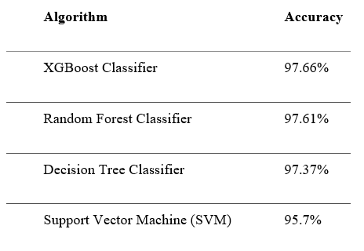
Figure 7 Accuracy of models for Panic Disorder detection.

Final Model Selection: The XGBoost Classifier achieved the best accuracy of 97.62% on the test dataset and 97.66% on the training dataset. This model is integrated into the platform to help identify users at risk of panic disorder.
Integration: Users provide details via sliders and dropdown menus in the Streamlit web interface. Categorical inputs are converted to numerical values, and the XGBoost model processes the input to return a binary prediction (0: low risk, 1: high risk). The output provides advice based on the risk level.

  - Social Media Mental Health Test
Dataset: Social Media and Mental Health Dataset [10] publicly available on Kaggle. It contains 7 demographic variables and 12 Likert-scale questions across 1,000+ entries. Key features include age, gender, time spent on social media, and mental health symptoms related to ADHD, anxiety, self-esteem, and depression. The target variable is a binary label (0 = no checkup recommended, 1 = checkup recommended).
Data Preprocessing: Involved dropping invalid gender entries and standardizing responses. Categorical 'Time Spent' values were converted to integers. Composite scores were created for ADHD, Anxiety, Self-Esteem, and Depression. Gender was mapped to integers for encoding.
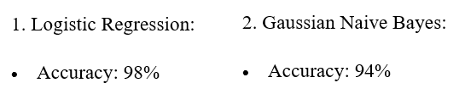
Model Development: Logistic Regression and Gaussian Naive Bayes models were tested.
Figure 8 Accuracy of models for Social Media Mental Health
Final Model Selection: The Logistic Regression model was chosen for deployment due to its higher accuracy of 98% and robust performance.
Integration: The Streamlit interface collects demographic and Likert-scale question inputs from users, processing them to recommend whether a mental health checkup is needed.

  - Anxiety Prediction Test
Dataset: Social Anxiety Dataset [11], publicly available on Kaggle with over 10,000 samples. Key features include demographics (Age, Gender, Occupation), lifestyle (Sleep Hours, Physical Activity, Diet Quality, Alcohol/Caffeine Use, Smoking), health metrics (Heart Rate, Breathing Rate, Stress, Sweating, Dizziness), mental health history (Therapy, Medication, Family History), and recent major life events. The target variable is 'Anxiety Level' on a 1–10 scale.
Data Preprocessing: Involved standardizing categorical variables (e.g., 'Non-binary' to 'Other'), dropping invalid entries, one-hot encoding 'Occupation' (13 categories), label-encoding 'Gender', binning continuous variables, and applying StandardScaler to normalize numerical features.
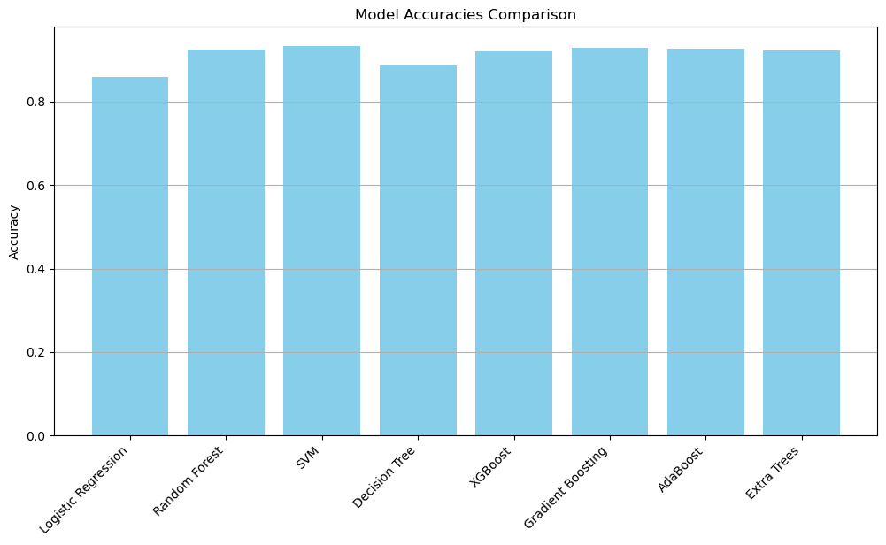
Model Development: The Support Vector Machine (SVM) model was chosen.
Figure 9 Accuracy of models for Anxiety
Integration: The Streamlit interface collects inputs such as stress level, sleep hours, caffeine intake, physical activity, therapy sessions, and occupation. The model then provides an output indicating low or high anxiety, recommending professional consultation if needed.
- AI-Powered Chatbot with Retrieval-Augmented Generation (RAG): The MindFul platform integrates an AI-driven chatbot to provide empathetic and context-aware mental health support. The chatbot leverages the RAG framework to combine real-time data retrieval with generative language models, ensuring responses are both accurate and tailored to user needs. The research-backed choice for RAG is based on studies like [12], which have proven its effectiveness in improving model performance in medical and mental health contexts.
  - Dataset Preparation and Curation:
Dataset Overview: The chatbot’s knowledge base is built on the Mental Health Counseling Conversations Dataset [13], a publicly available corpus comprising 3,512 anonymized therapist-client dialogues sourced from online counseling platforms.
Key Characteristics: Each instance includes a 'Context' (user’s mental health query) and a 'Response' (psychologist’s answer). It covers diverse topics such as anxiety, depression, relationship issues, and coping strategies. Ethical compliance was ensured through data anonymization, removing personally identifiable information (PII).
Preprocessing Pipeline: Raw dialogues were converted into structured question-answer pairs (CSV) for supervised fine-tuning. Documents were segmented into 1,000-character chunks using CharacterTextSplitter to optimize retrieval granularity. Non-therapeutic content was filtered to ensure clinical relevance.
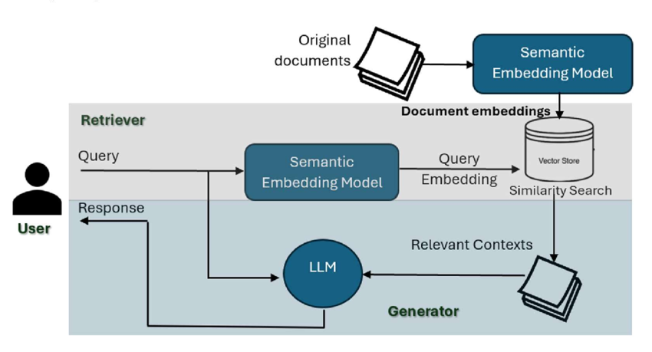
  - RAG Architecture Design:
Figure 10 RAG Architecture
Retrieval Phase: Utilizes the sentence-transformers/all-mpnet-base-v2 embedding model to generate 768-dimensional semantic embeddings for queries and documents. Pinecone’s serverless index (mindful-chatbot) enables low-latency similarity searches using cosine similarity. For each user query, the top 3 relevant document chunks are retrieved to ground responses in verified therapeutic strategies.

Generation Phase: The core language model used is MistralAI’s Mixtral-8x7B-Instruct-v0.1 [9]. This sparse mixture-of-experts (MoE) model was selected for its open-source nature, cost efficiency (no per-token licensing fees), and high performance (outperforms comparable models in instruction-following tasks with a 32k-token context window).

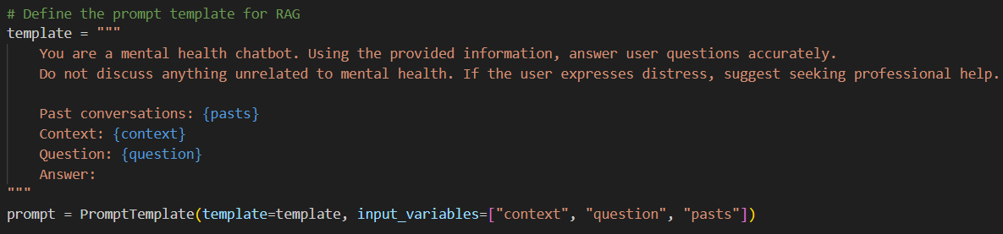
Prompt Engineering: A safety-focused template restricts responses to mental health topics and mandates crisis intervention protocols.
Figure 11Prompt
Post-Processing: Regex filters (e.g., re.search(r"Answer:\s*(.*)", result)) extract the final response, discarding extraneous model output.

  - System Integration:
The chatbot's backend logic and models are hosted on Hugging Face, providing a scalable and accessible API endpoint for the frontend. MongoDB logs conversations under unique session_id for continuity and compliance auditing. API keys for Pinecone and Hugging Face are isolated in .env files to prevent exposure in version control. Mixtral’s ability to synthesize retrieved therapeutic strategies (from Pinecone) with user-specific context ensures responses are both clinically informed and empathetic.

4.2 Key components/modules of the system
The MindFul platform is structured into several interconnected key components, each serving distinct functionalities to provide a comprehensive mental health support system:
- User Management Module: Manages user registration, login, authentication, and overall account administration, ensuring secure access and personalized experiences.
- AI-Powered Psychological Tests Module: Integrates various machine learning models to offer standardized psychological assessments. Users can complete these tests to receive initial evaluations of their mental health status, guiding them towards understanding their symptoms.
- AI-Driven Chatbot Module: Features an intelligent assistant designed to engage users in natural conversations, providing immediate guidance, emotional support, and relevant mental health information.
- Stories Module: A dedicated, safe space for users to share personal experiences, coping strategies, and provide peer support, fostering a sense of community and reducing isolation.
- Therapists Section (Doctor Directory) Module: Allows licensed mental health professionals to register and publish educational content. It also provides a directory for users to find psychiatrists' locations, availability, and contact information, facilitating access to professional help.
- Mental Health Articles Module: A platform where doctors can publish informative content, research, and news about mental health conditions, treatment advancements, and coping strategies, aiming to raise awareness and provide guidance.
- Positive Notifications System: Delivers regular motivational messages and mental wellness tips directly to users, designed to uplift spirits and encourage self-care practices throughout the day.
- Feedback Mechanism: Incorporates a system for users to report issues, suggest improvements, or provide general feedback about their platform experience.

4.3 Challenges faced and how they were resolved.
During the implementation of MindFul, several technical and data-related challenges were encountered. These were systematically addressed to ensure the platform's robustness and accuracy:
- Categorical Encoding Conflict in Psychological Tests:
  - Problem: The initial code used a global dictionary for encoding categorical values, leading to overlapping mappings where distinct categorical values from different features were mapped to the same integer (e.g., "No" in 'Family History' and "No" in 'Personal History' sharing the same numerical representation).
  - Resolution: Column-specific encoding was implemented. This approach ensured unique mappings for each categorical feature, preventing conflicts and improving data integrity for model training.
- Missing Value Handling in Datasets:
  - Problem: Columns such as 'Medical History' (25.2% null), 'Psychiatric History' (24.9% null), and 'Substance Use' (33.4% null) in datasets like the Panic Disorder Detection Dataset contained a significant number of null values.
  - Resolution: Null values were strategically replaced with a dedicated categorical label ("None") before encoding. This method allowed the retention of all 100,000 samples and ensured that missingness itself could be treated as a meaningful feature for the models.
- Ensuring Contextual Relevance and Reducing Hallucinations in Chatbot:
  - Problem: Large Language Models (LLMs) can sometimes generate responses that are not contextually accurate or may "hallucinate" information if they rely solely on their pre-trained knowledge, which might be outdated or too general for mental health contexts.
  - Resolution: The Retrieval-Augmented Generation (RAG) framework was implemented to address this. RAG enhances LLMs by integrating external, reliable knowledge sources. For MindFul, this involved using the Mental Health Counseling Conversations Dataset with Pinecone as a vector database. When a user queries, the RAG system retrieves relevant document chunks, which then augment the LLM's prompt, grounding its responses in verified therapeutic strategies. Additionally, prompt engineering was used to restrict responses to mental health topics and mandate crisis intervention protocols.
- Seamless Integration Between Front-end and Back-end:
  - Problem: Ensuring efficient and secure communication between the React front-end and the Node.js/Express.js back-end, especially when hosted on different domains (e.g., Vercel for front-end).
  - Resolution: A set of RESTful API endpoints was exposed by the back-end to handle specific operations like user registration, data submission, and retrieval. Axios was utilized on the front-end to send and receive data via HTTP requests. JSON data format was adopted for lightweight and readable data exchange. Cross-Origin Resource Sharing (CORS) was configured on the server to allow secure requests from different origins. Environment variables were used to manage sensitive data such as API URLs and database connection strings securely.

Chapter 5

Testing & Evaluation

5.1 Testing strategies (unit testing, integration testing, user testing)
System testing is a vital phase in the software development lifecycle, conducted to ensure that the entire integrated application performs according to specified requirements. For the MindFul platform, a comprehensive strategic testing approach was adopted to ensure functionality, performance, security, and usability.
- Unit Testing:
Individual components were tested to ensure correct functionality.
  - Frontend: React components were tested for correct rendering and state handling.
  - Backend: API routes and data processing logic were tested individually.
  - AI Models: The AI-based psychological test evaluation module was tested with mock data to confirm prediction accuracy. The integrated AI chatbot was also unit tested for conversational flow, response relevance, and its ability to provide appropriate mental health guidance based on user input.
- Integration Testing:
Ensured seamless interaction and data flow between different system modules.
  - Frontend-Backend Communication: Tested through Axios/API requests to confirm data transfer and response handling.
  - Chatbot and AI Module Integration: Ensured the Retrieval-Augmented Generation (RAG) system delivers correct and contextually relevant responses when integrated with the LLM.
  - Database Connectivity: Confirmed successful integration with the MongoDB database for the therapists’ section, articles section, and stories posts.
- System Testing:
Verified the behavior of the full application under real-world conditions. This included ensuring responsiveness across devices and consistent design, accurate data input/output, smooth integration of AI components, and user-friendly error handling.
  - Test Scenarios included: User registration and login, completing and submitting mental health tests, interacting with the chatbot, posting and Browse in the stories section, therapist registration and profile creation, therapists writing/editing/publishing articles, users Browse articles, secure handling of personal/medical data, and receiving/displaying positive notifications.
- Acceptance Testing:
Conducted from the user's perspective to ensure the system meets expectations in usability, performance, and functionality.

5.2 Performance metrics (accuracy, speed, scalability, etc.)
The MindFul system was evaluated based on key performance metrics to ensure its effectiveness and reliability:
- AI Model Accuracy:
  - Panic Disorder Prediction: The XGBoost Classifier achieved a high accuracy of 97.62%
  - Social Media Mental Health: The Logistic Regression model achieved 98% accuracy.
  - Anxiety Prediction: The SVM model achieved 93.45% accuracy.
- Chatbot Accuracy and Coherence: The chatbot consistently delivers contextually relevant, empathetic, and coherent responses, accurately interpreting user input and maintaining meaningful conversation flow aligned with psychological support goals.
- Functionality: All major functions operate as expected.
- Performance: The frontend loads efficiently, and backend APIs respond under expected load.
- Security: User data is protected through server-side validation and access control mechanisms, ensuring privacy, confidentiality, and integrity.
- Usability: Focuses on ease of use, accessibility, and user interface design to ensure the website is user-friendly.
- Scalability: The platform should be able to scale effectively with increased traffic and content without significant performance degradation.
- Reliability: The website is designed to be available and reliable, with minimal downtime.

5.3 Comparison with existing solutions (if applicable)
MindFul differentiates itself significantly from existing mental health support platforms by offering a unique combination of features specifically tailored to the Egyptian context:

- Shezlong (Egypt & Arab World): While Shezlong provides online therapy sessions and is available in Arabic, it lacks community features like story sharing or AI-powered tools. MindFul uniquely integrates a supportive community and advanced AI-powered psychological tests, offering a more holistic approach beyond just therapy sessions.
- Woebot (United States): Woebot is an AI-powered chatbot offering 24/7 instant support. However, it lacks human therapist interaction. MindFul, conversely, combines an AI-driven chatbot with a comprehensive psychiatrist directory, bridging the gap between AI support and access to professional human help.
- BetterHelp (Global): BetterHelp provides online therapy sessions globally with flexible communication options. Nonetheless, it does not feature community-driven aspects or AI-powered psychological tests. MindFul distinguishes itself by fostering a community where users can share stories and by providing personalized assessments through AI-powered psychological tests.

- Unique Value Proposition of MindFul:
  - Supportive Community: Users can share stories and connect, creating a safe environment.
  - Doctor-Approved Content: Articles and posts by certified psychiatrists ensure reliability and address the lack of awareness.
  - AI-Powered Psychological Tests: Machine learning provides accurate, personalized assessments.
  - Psychiatrist Directory: Users can find psychiatrists’ locations, availability, and contact information, bridging the gap between tech and real-world expertise and improving access to care.
  - Cultural Relevance: Tailored to address Egyptians' unique mental health needs, which is a significant gap in global platforms.
  - Centralized Platform: Addresses the absence of a centralized platform for mental health concerns.
In essence, MindFul is not just another mental health platform; it’s a community-driven solution designed specifically for Egyptians, aiming to overcome local challenges like stigma and limited access through a comprehensive and integrated set of features.

Chapter 6

Results & Discussion

6.1 Introduction
This chapter presents the key findings from the development and testing of the MindFul platform. It summarizes the results achieved, interprets their significance in relation to the project's objectives, and acknowledges any limitations of the proposed solution. The aim is to demonstrate how MindFul successfully addresses the identified problems in mental health support.

6.2 Summary of findings
The development and testing phases of the MindFul platform yielded positive results across various components:
- AI Model Accuracy:
  - The Panic Disorder Prediction Model (XGBoost Classifier) demonstrated high accuracy, achieving 97.62% .
  - The Social Media Mental Health Test (Logistic Regression) achieved an accuracy of 98%.
  - The Anxiety Prediction Test (SVM) achieved an accuracy of 93.45%.
- Chatbot Performance: The chatbot, utilizing RAG and fine-tuned Mixtral-8x7B-Instruct-v0.1, consistently delivered contextually relevant, empathetic, and coherent responses. It accurately interpreted user input and maintained meaningful conversation flow aligned with psychological support goals.
- System Functionality: All major functions of the platform, including user registration, mental health tests, chatbot interaction, story posting, therapist profiles, and article Browse, operated as expected.

- User Interface and Experience: The frontend loads efficiently, and the backend APIs respond under expected load, contributing to a smooth user experience. The interface is designed to be user-friendly and responsive across various devices.
- Security: Robust security measures, including server-side validation, were implemented to protect user data and ensure privacy. Data privacy and security are handled in line with healthcare data protection standards.

6.3 Interpretation of results
Based on the findings, the MindFul project successfully met its primary and specific objectives:
- Increased Awareness and Reduced Stigma: By providing comprehensive information through doctor-approved articles and offering a safe community for sharing stories, the platform actively promotes mental health awareness and helps reduce the associated stigma. The content is tailored to address the unique mental health needs of Egyptians.
- Improved Accessibility and Connection: The web-based platform ensures 24/7 accessibility to mental health support. The psychiatrist directory effectively facilitates connections with professionals, bridging geographical gaps, especially in remote areas where access is limited.
- Enhanced Personalization: The high accuracy of the AI-powered psychological tests allows for personalized initial assessments, guiding users towards understanding their symptoms. The RAG-enhanced chatbot provides context-aware support tailored to individual user needs.

- Provision of Reliable Resources: The use of doctor-approved content and research-backed AI models ensures the reliability and accuracy of the information and support provided.
- User Privacy and Security: The implementation of robust server-side validation and adherence to data protection standards confirms the platform's commitment to user privacy and data security.
Overall, MindFul demonstrates its potential as an accurate, efficient, and accessible platform that effectively bridges the gap between individuals and mental health support systems, contributing to improved quality of life and fostering healthier, more resilient societies.

6.3 Limitations of the proposed solution
While MindFul offers a robust solution, certain limitations were identified during its development and testing:
- Resource Intensiveness for AI Testing: Testing AI behavior under varied edge cases can be resource-intensive, requiring significant computational power and time.
- Reliance on Simulated Data for Testing: Comprehensive mental health testing for AI models often requires simulated data, which, while useful, may not fully capture the complexities and nuances of real-world user interactions and conditions.
- Initial Scope of Disorders: While the psychological tests cover Panic Disorder, Social Media Mental Health, and Anxiety, the current scope does not encompass all mental health conditions.

- Human Therapist Interaction Limitation: Although a doctor directory is provided, the platform itself does not facilitate direct human-to-human therapy sessions (e.g., video calls) within its core features, relying instead on connection outside the platform.
- Language Support: The current implementation primarily focuses on English and Arabic, as the Mixtral model has multilingual capabilities, but full multilingual support for all content and features across diverse languages might require further development.

Chapter 7

Conclusion & Future Work

7.1 Summary of contributions
The development of MindFul marks a significant step toward leveraging technology to address mental health challenges. The project successfully delivered a comprehensive mental health support platform by integrating several key contributions:
- Integrated Mental Health Support: MindFul provides a unique integrated platform offering psychological assessments, AI-driven chatbot support, therapist collaboration, and community interaction. This holistic approach distinguishes it from many existing solutions.
- AI-Powered Assessment and Support: The implementation of highly accurate AI models for panic disorder, social media mental health, and anxiety prediction provides users with valuable initial psychological insights. The RAG-enhanced chatbot offers empathetic and context-aware guidance.
- Community-Driven Engagement: The "Stories" section fosters a supportive environment where users can share experiences, reducing isolation and promoting open dialogue around mental health.
- Improved Access to Professionals: The psychiatrist directory effectively bridges the gap between individuals seeking help and licensed mental health professionals, enhancing access to care, particularly in underserved areas.
- Reliable and Culturally Relevant Content: By incorporating doctor-approved articles and tailoring content to the unique mental health needs of Egyptians, MindFul ensures the provision of reliable and culturally appropriate information.
- Secure and Accessible Platform: Through rigorous system testing, the platform's functionality, reliability, and security were confirmed, ensuring a user-friendly and secure environment for both users and professionals.

7.2 Possible improvements or extensions for future work
The MindFul project has a strong foundation and significant potential for future enhancements and expansions to further improve mental health support:
- Mobile Application Development: Creating a dedicated mobile app version would significantly increase accessibility and engagement on smartphones, providing continuous support to users.
- Voice Interaction: Integrating voice-based chatbot interaction could improve accessibility, especially for users with reading difficulties or those who prefer verbal communication.
- Advanced AI Recommendations: Enhancing the AI to offer more personalized content, articles, and coping strategies based on individual user behavior, psychological test results, and interaction patterns.
- Multilingual Support: Expanding support to include multiple languages beyond English and Arabic would allow MindFul to reach a broader and more diverse user base globally.
- Therapist–Patient Communication Tools: Adding features such as secure in-platform messaging or video consultation capabilities would directly facilitate communication between therapists and users, offering more integrated care.

- Progress Tracking Dashboard: Developing a dashboard that allows users to view their test history, mood patterns, and interaction summaries over time could empower them to track their mental wellness journey.
- Gamification: Implementing gamification elements such as badges, rewards, or challenges could encourage consistent usage and participation in mental wellness activities, fostering better habits.
- Emergency Support Integration: Adding direct connections to emergency hotlines or nearby mental health crisis centers for immediate support in critical situations.

References

[1] World Health Organization. (2022). Mental disorders. https://www.who.int/news-room/fact-sheets/detail/mental-disorders
[2] World Health Organization. (2025). Suicide. https://www.who.int/news-room/fact-sheets/detail/suicide
[3] Mistral AI. (n.d.). Model Overview. https://docs.mistral.ai/getting-started/models/models_overview/
[4] Nayinzira, J., & Adda, M. (2024). SentimentCareBot: A Sentiment-Aware Retrieval-Augmented Generation Chatbot. Procedia Computer Science, 231, 1815–1824. https://doi.org/10.1016/j.procs.2024.04.185
[5] Ezhilmaran, D., & Kannan, S. (2022). Mental Health Prediction Using Machine Learning. Academia.edu. https://www.academia.edu/94614967
[6] Sumitha, S., Muthulakshmi, M., & Yadav, P. (2023). Mental Illness Prediction Using ML Algorithms. Academia.edu. https://www.academia.edu/107403197
[7] Rahaman, S. A. (2023). Predicting Anxiety, Depression, and Stress Using ML. Academia.edu. https://www.academia.edu/92091604
[8] Mistral AI. (2023, December 11). Mixtral of experts. https://mistral.ai/news/mixtral-of-experts
[9] Muhammad Shahid Azeem. (n.d.). Panic Disorder Detection Dataset [Dataset]. Kaggle. https://www.kaggle.com/datasets/muhammadshahidazeem/panic-disorder-detection-dataset
[10] Souvik Ahmed. (n.d.). Social Media and Mental Health [Dataset]. Kaggle. https://www.kaggle.com/datasets/souvikahmed071/social-media-and-mental-health [11] Nate Zhang. (n.d.). Social Anxiety Dataset [Dataset]. Kaggle. https://www.kaggle.com/datasets/natezhang123/social-anxiety-dataset

[12] J. P. Nayinzira and M. Adda, "SentimentCareBot: Retrieval-Augmented Generation Chatbot for Mental Health Support with Sentiment Analysis," in Procedia Computer Science, vol. 229, pp. 1234–1240, Dec. 2024. [Online]. Available: https://doi.org/10.1016/j.procs.2024.12.345
[13] Amod. (n.d.). Mental Health Counseling Conversations [Dataset]. Hugging Face. https://huggingface.co/datasets/Amod/mental_health_counseling_conversations

Appendices

User Manuals

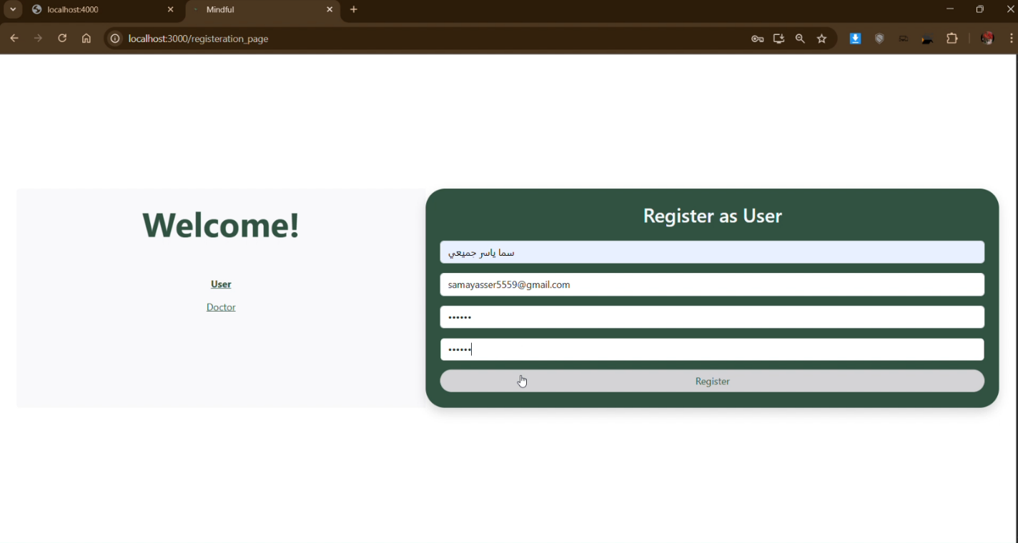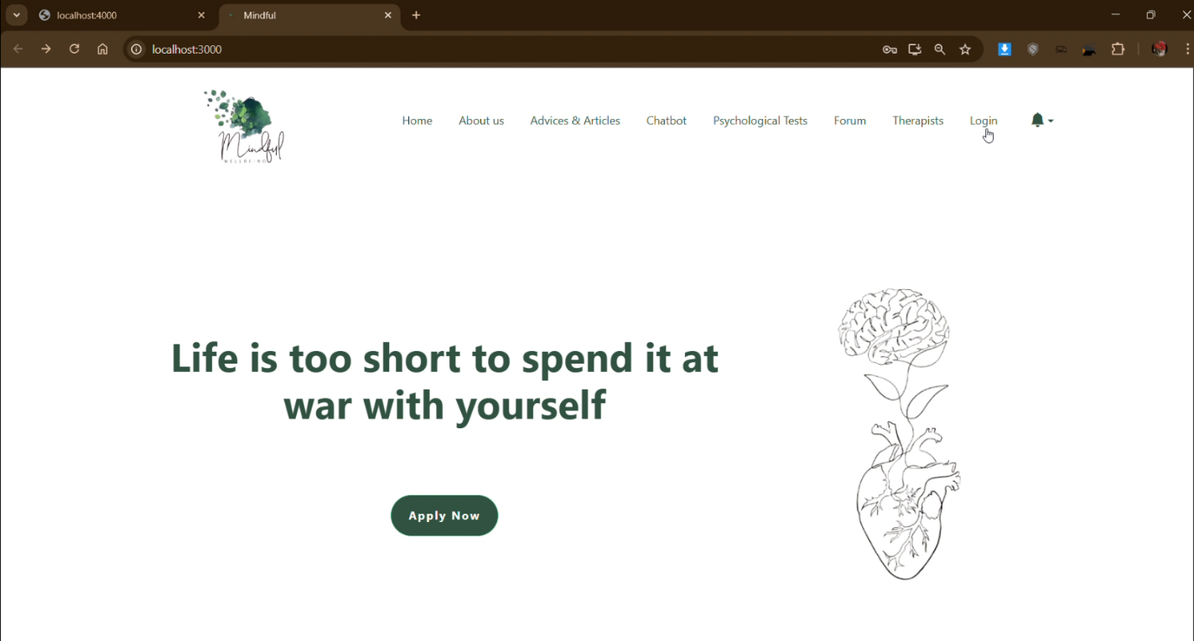
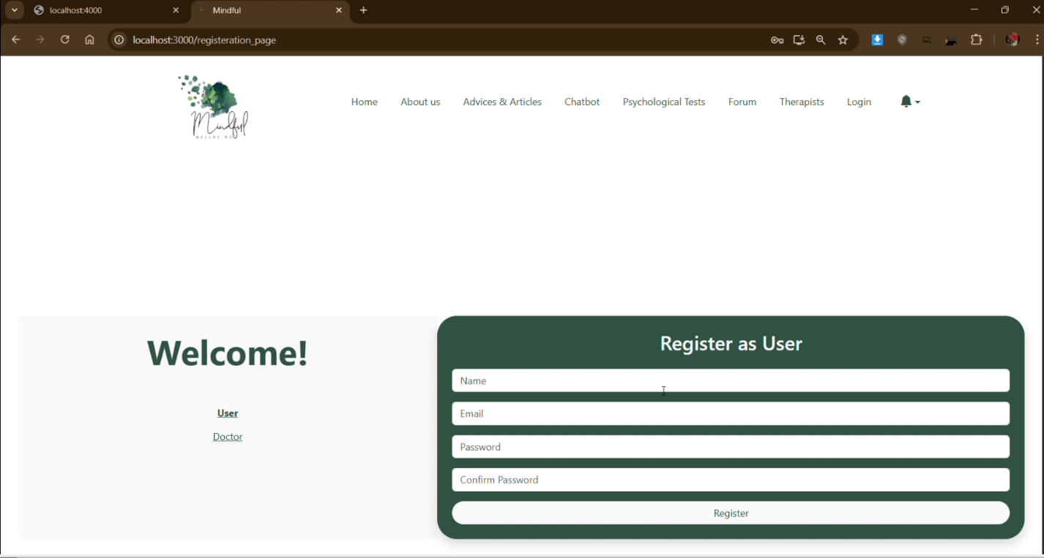
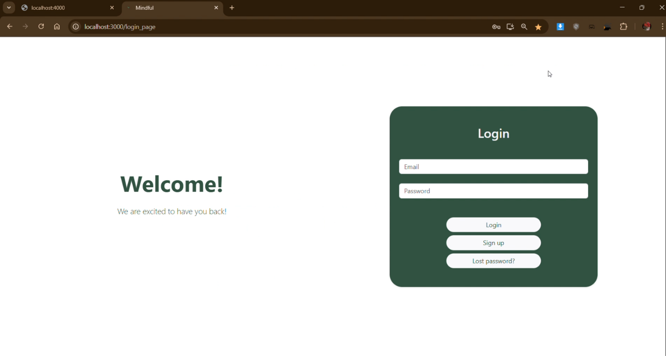

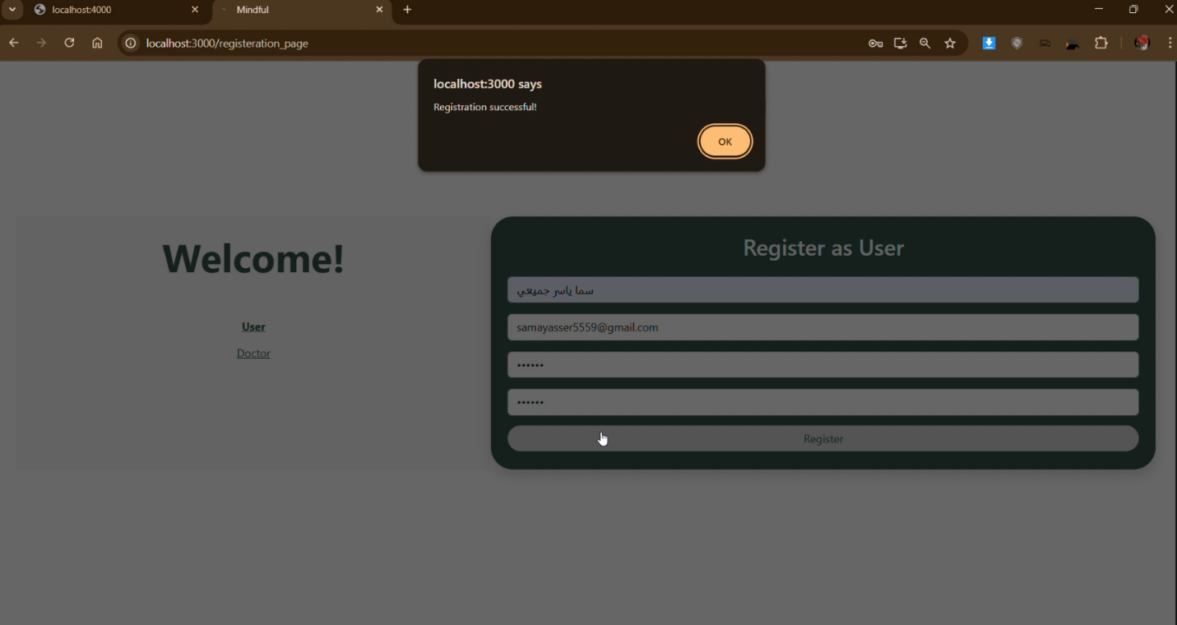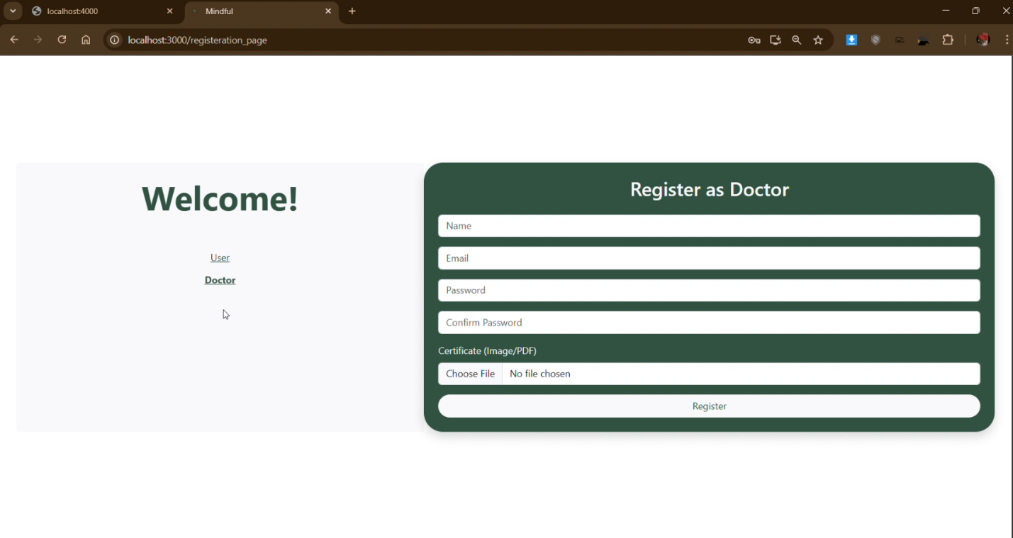

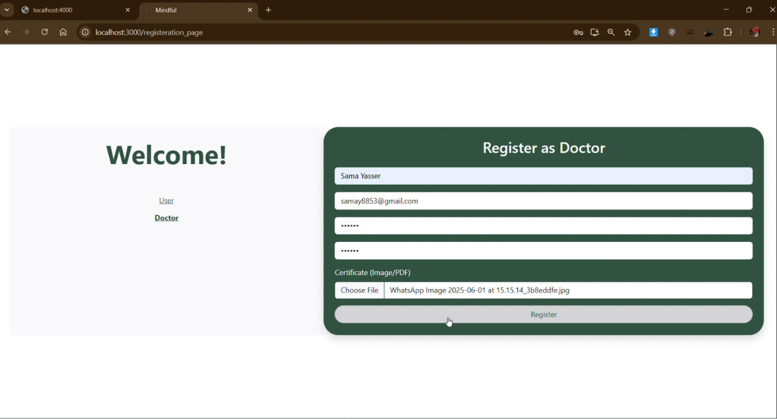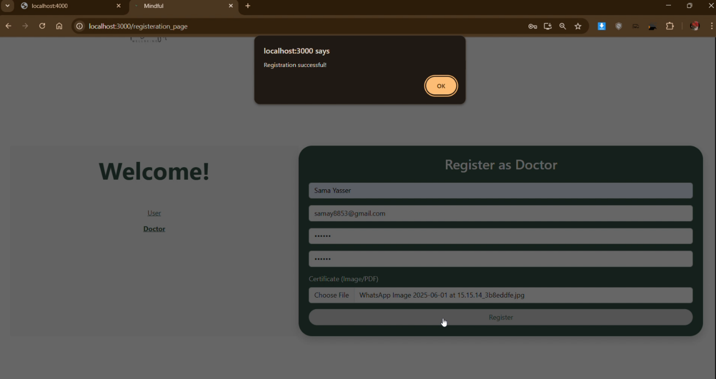

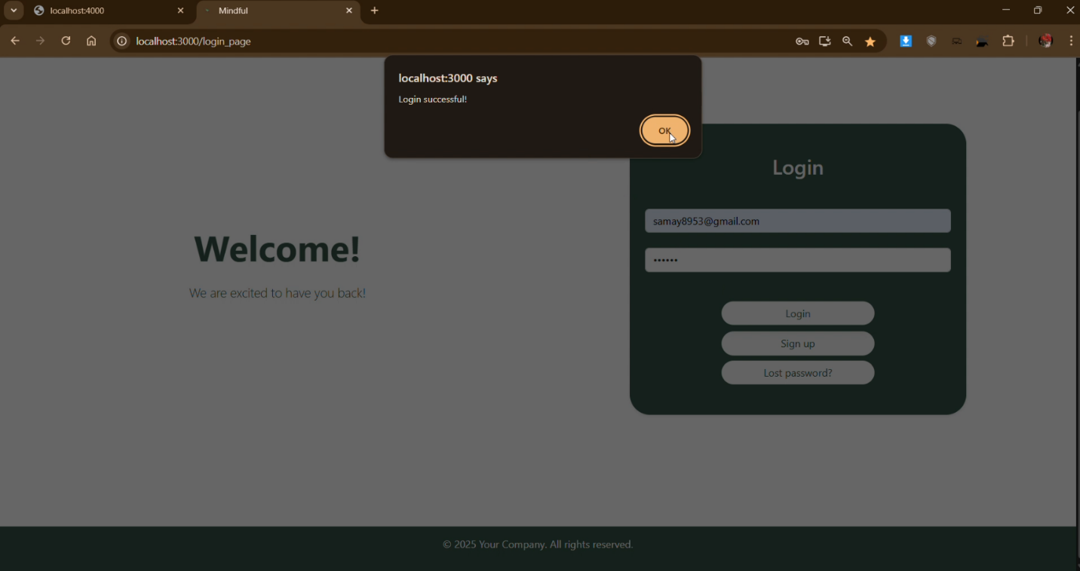


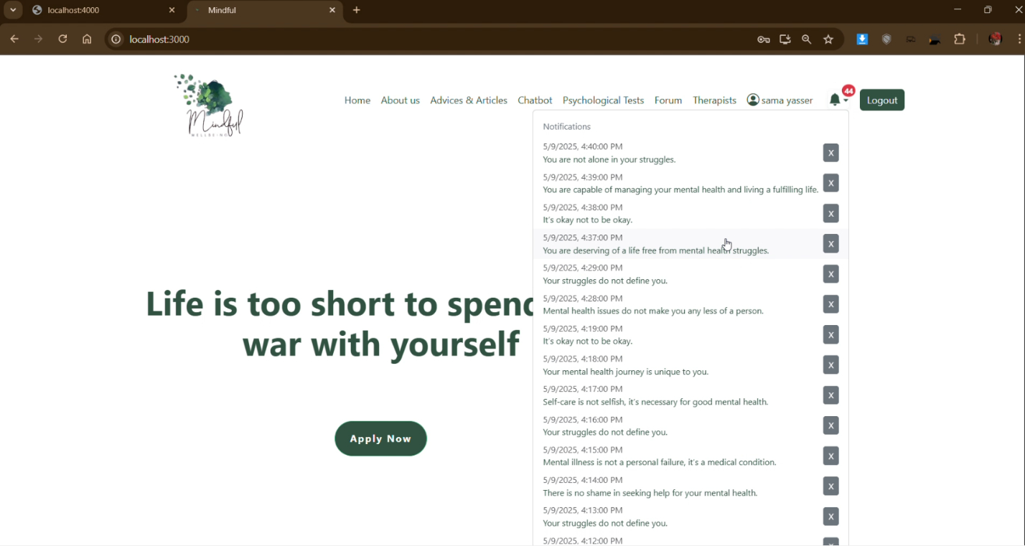

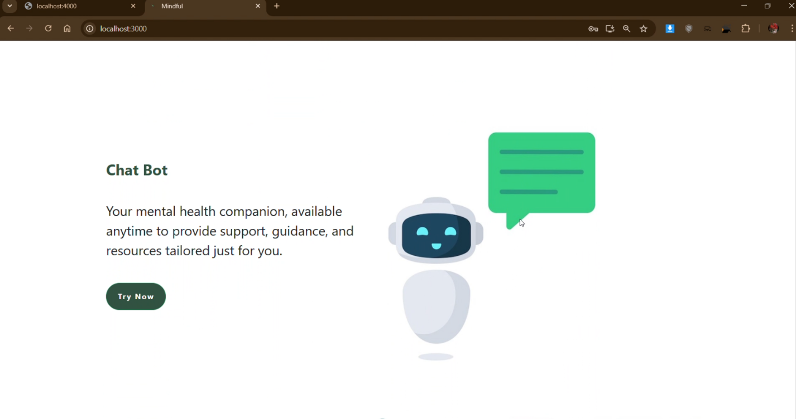



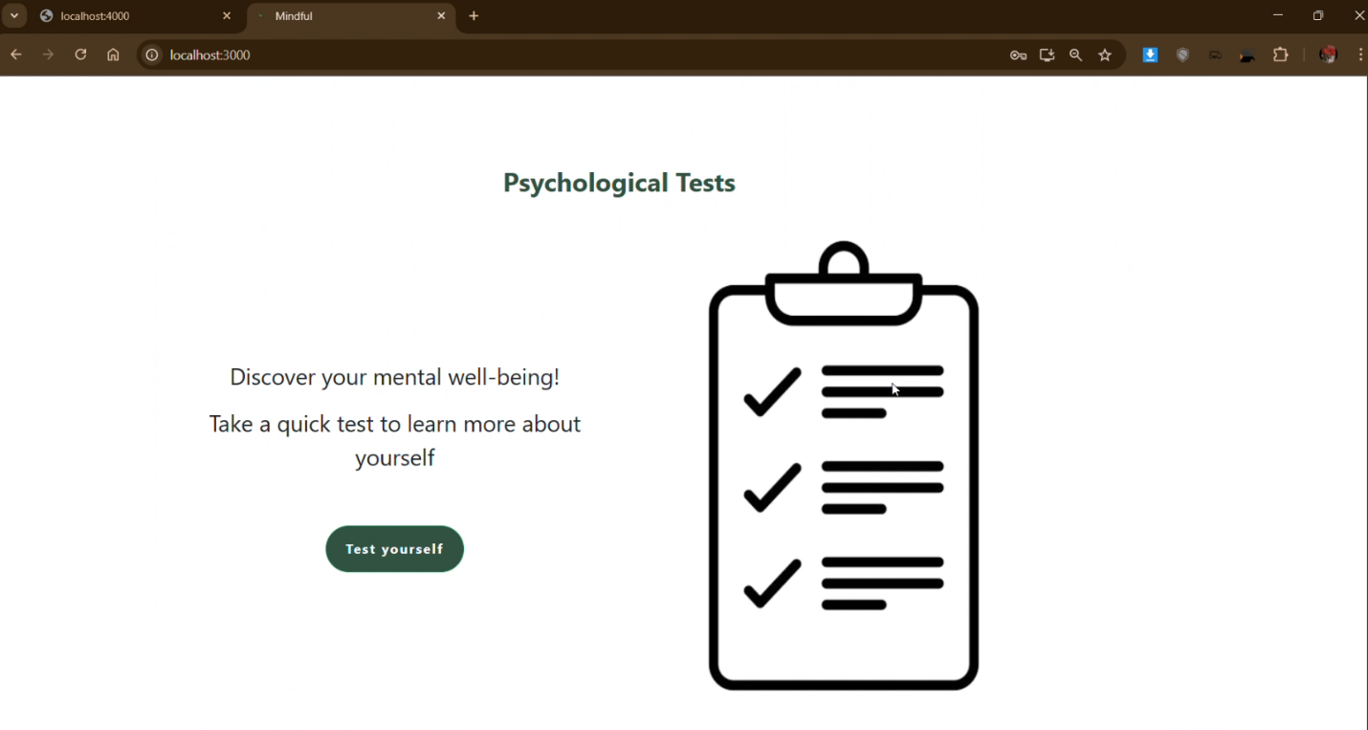

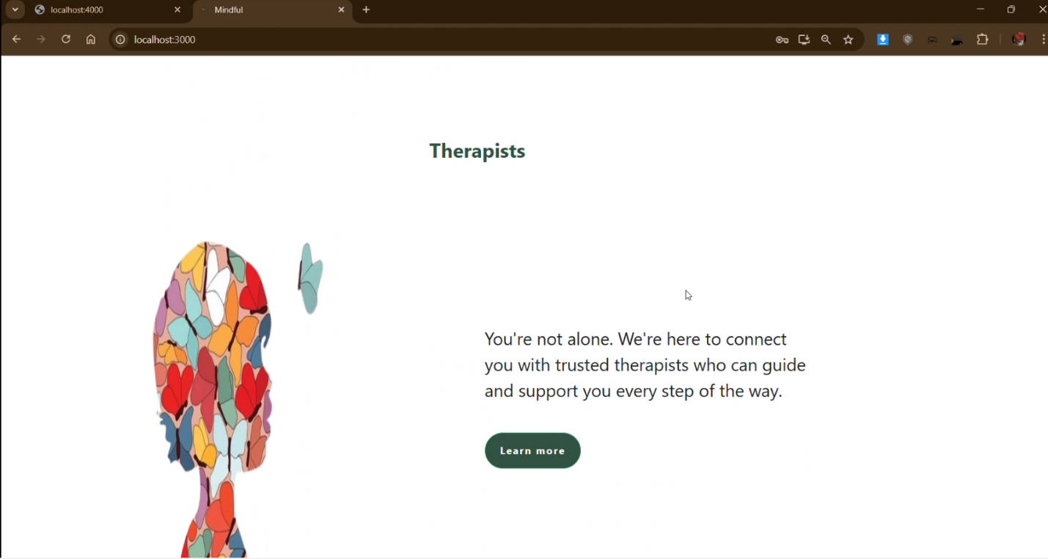
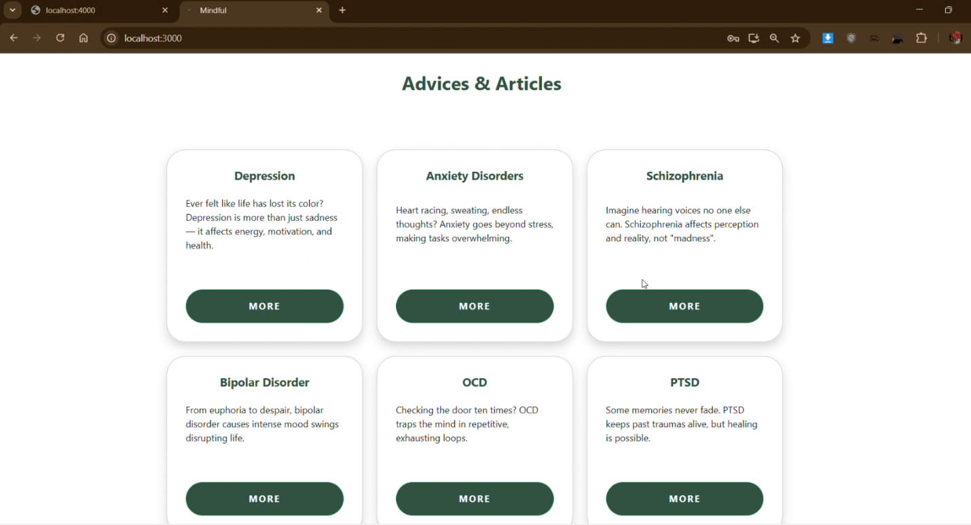

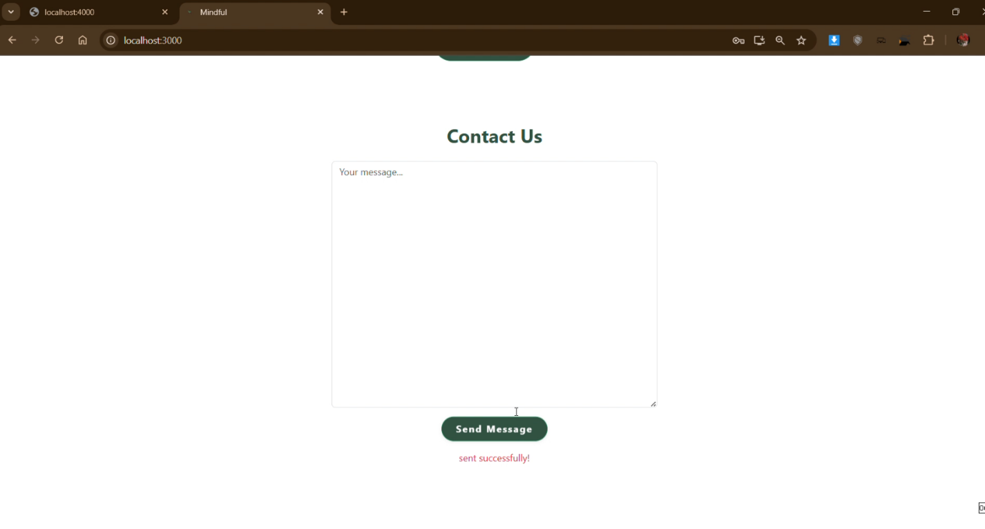
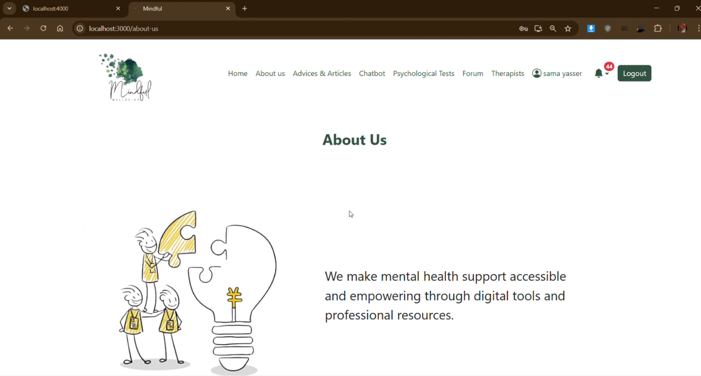

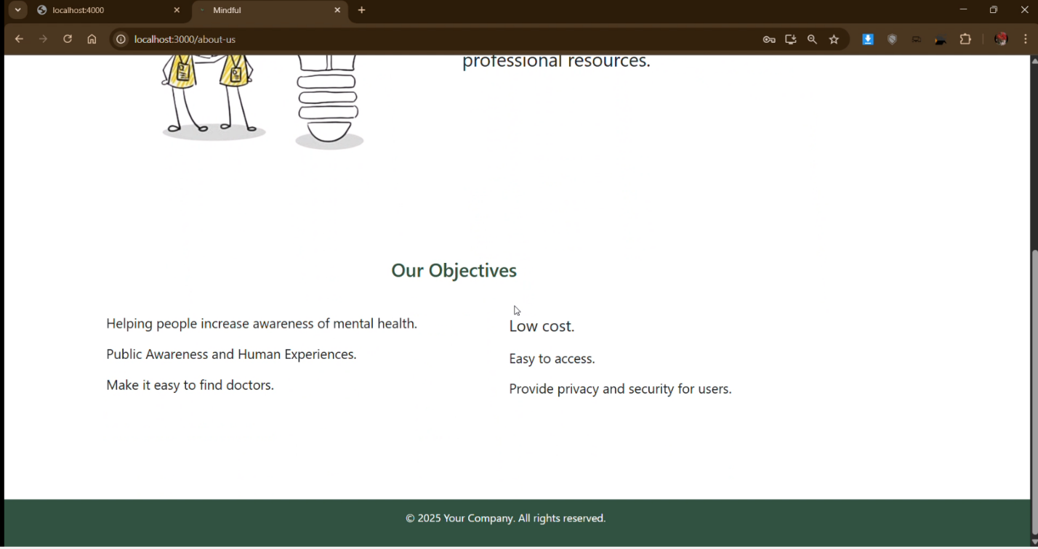
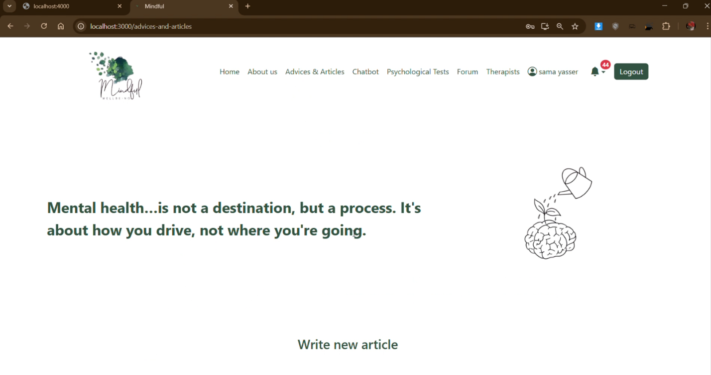

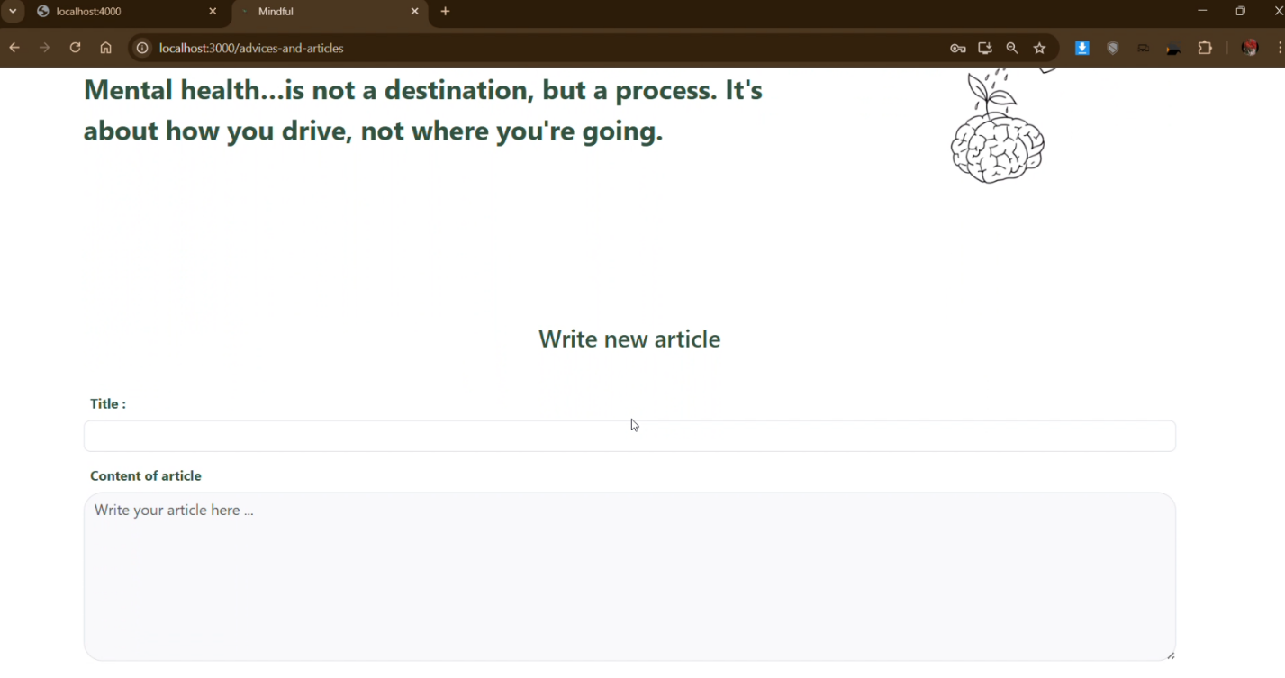
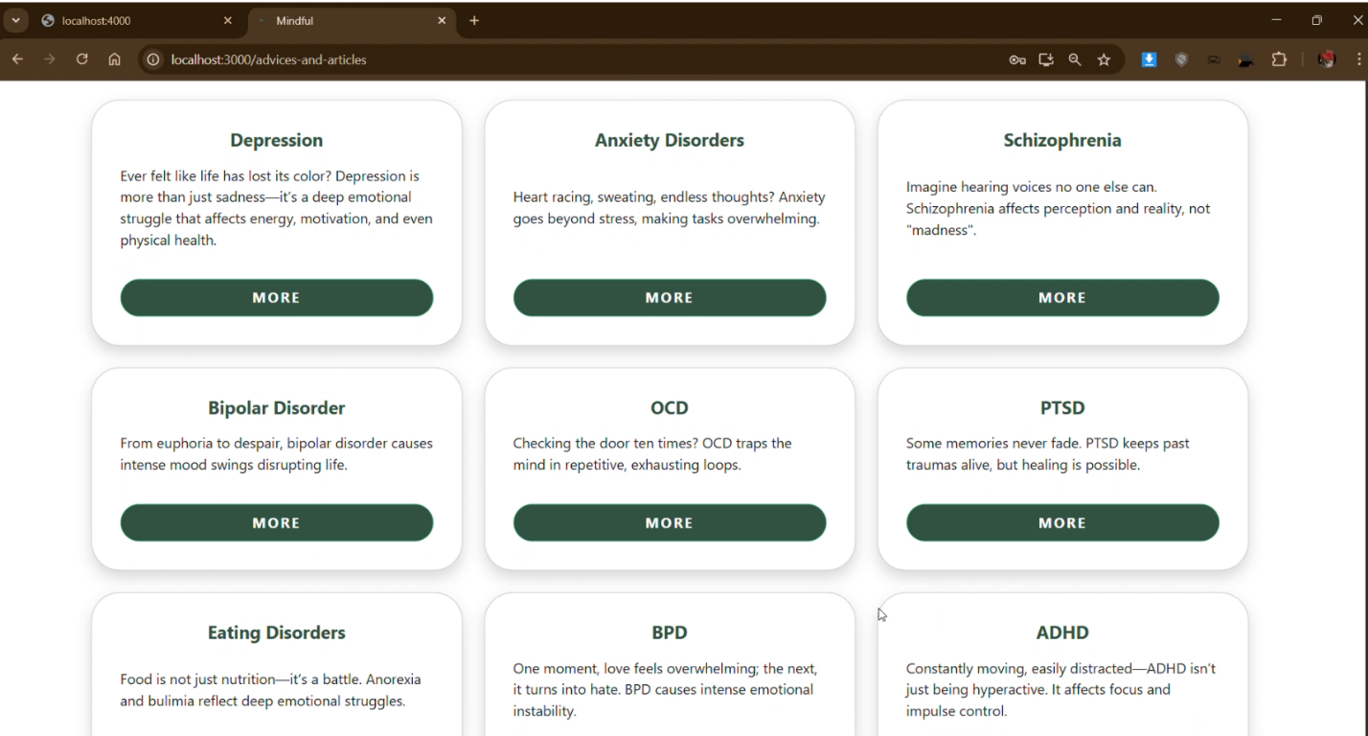

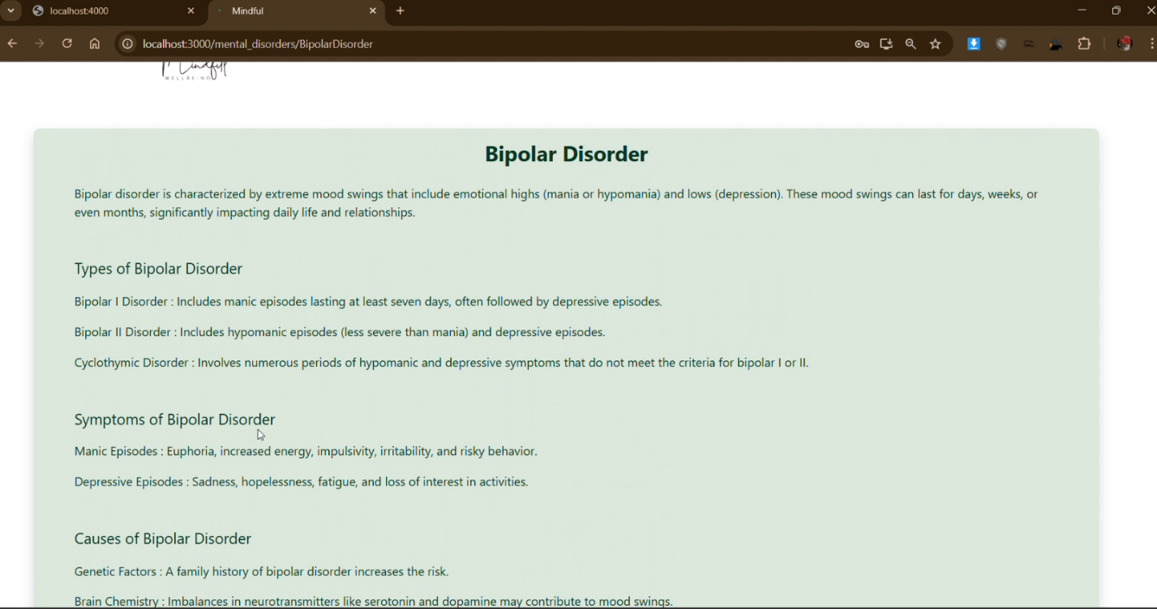
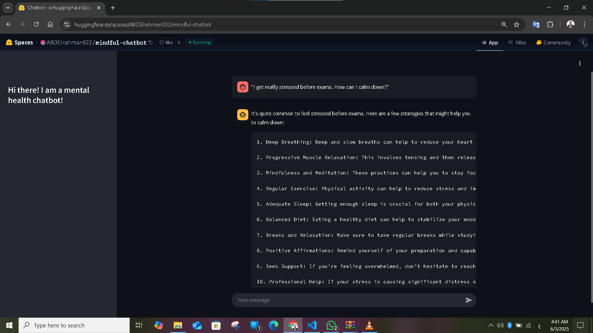

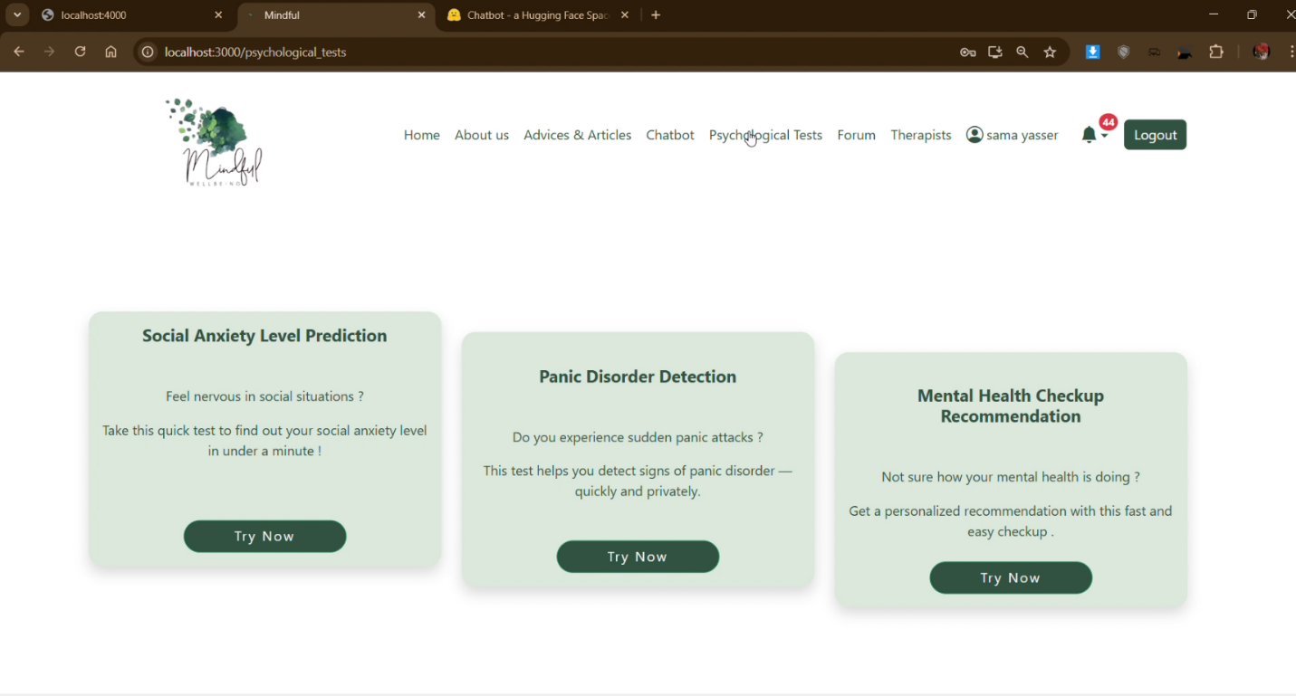
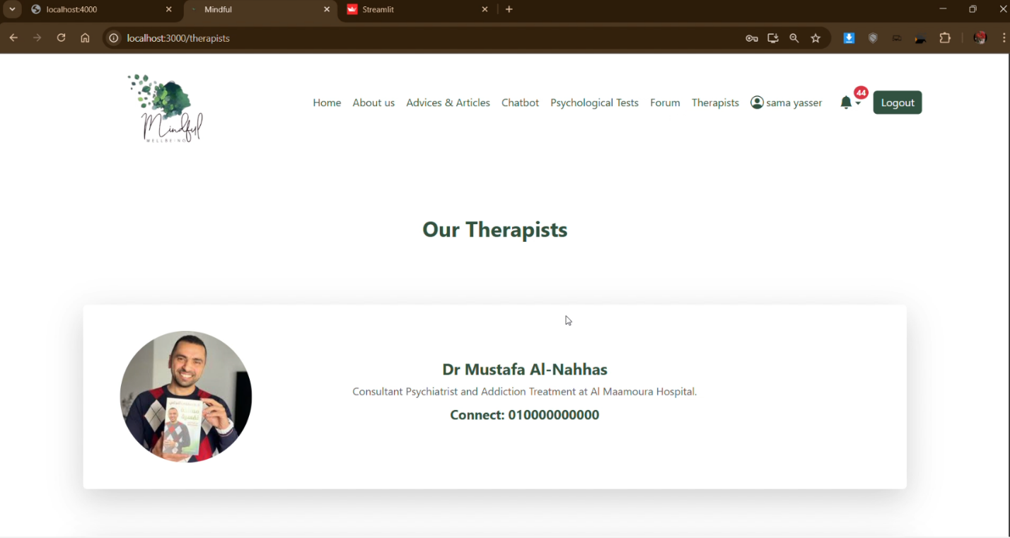

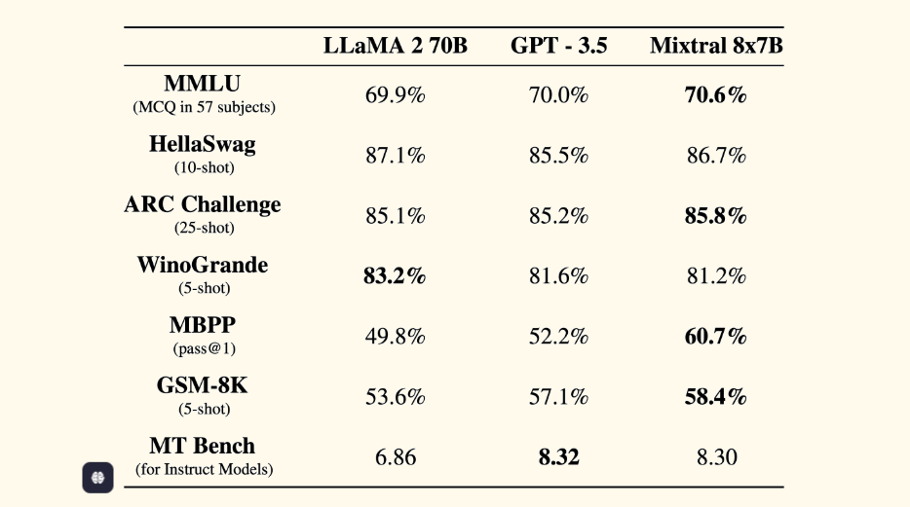
Figure A.1: Performance comparison between LLaMA 2 70B, GPT-3.5, and Mixtral 8x7B across standard benchmarks such as MMLU, HellaSwag, ARC Challenge, WinoGrande, MBPP, GSM-8K, and MT Bench. [8]
Figure 12 Performance comparison between LLaMA 2 70B, GPT-3.5, and Mixtral 8x7B

Project Source Code Repository:
The full implementation of the project, including all components — data, AI models, and the web interface — is available on GitHub:
GitHub Repository: https://github.com/ABDElrahman022/Mindful-GP
This repository contains: AI Models, datasets, and Web Application

